 | University of Central Punjab  Faculty of Information Technology  Lab Manual Week 3 – Fall 2025
Subject | Software Construction and Development | Course Code | SESD3242
Sections
Allowed Time |  | %contribution towards final lab evaluation

INSTRUCTIONS
- Read the tasks carefully (Understanding is the part of the lab tasks).
- All tasks are mandatory. Only appropriate queries would be entertained by the lab instructor.
- Exchange of tasks is not allowed.
- Submit the tasks within prescribed time.
Topic: Creating and Managing a Scrum Board using Jira/ trello
Student Learning Outcomes:
After completing this lab, students will be able to:
Understand and apply the Agile and Scrum framework using Jira.
Create a Scrum project and configure a Scrum board.
Define Product Backlog, Sprints, and User Stories.
Assign tasks to team members and track progress through the Scrum board.
Use Jira features such as Epics, Issues, Burndown charts, and Sprint reports.
Lab Environment Setup
- Open https://www.atlassian.com/software/jira
- Sign up for a free Jira Software account using university email.
- Select “Scrum Software Development” template.
- Choose Team-managed project for simplicity.
- Name the project: “Student Scrum Practice - <YourName>”

Task 1: Create a Scrum Project
Create a new Jira project named “Online Bookstore Management System” using the Scrum template.
Choose team-managed type.
Add at least 3 team members.
Identify the Product Owner, Scrum Master, and Developers among your team.

Deliverable: Screenshot of created project and team members.
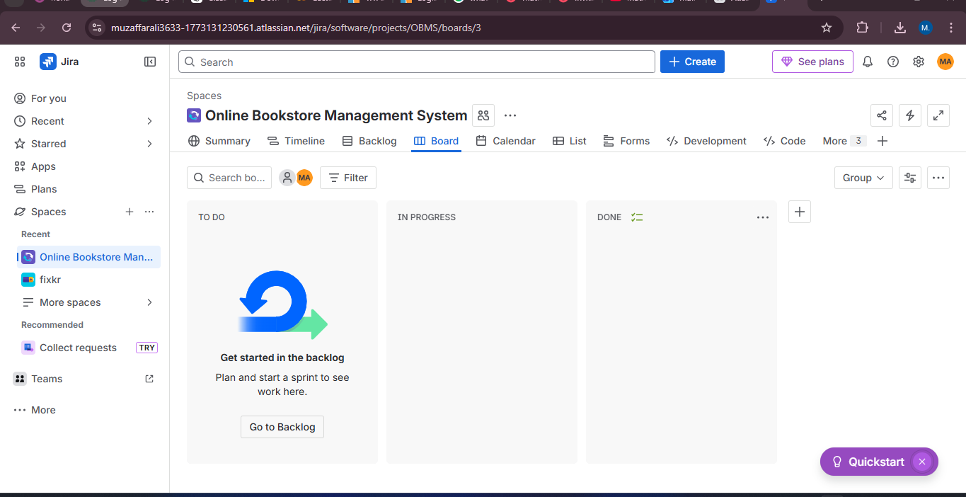

Task 2: Create Product Backlog
Create the Product Backlog for your project. Add at least 5 user stories, for example:
As a user, I want to create an account so that I can save my favorite books.
As an admin, I want to manage book inventory so that I can update availability.
Deliverable: Screenshot of the backlog with all user stories.
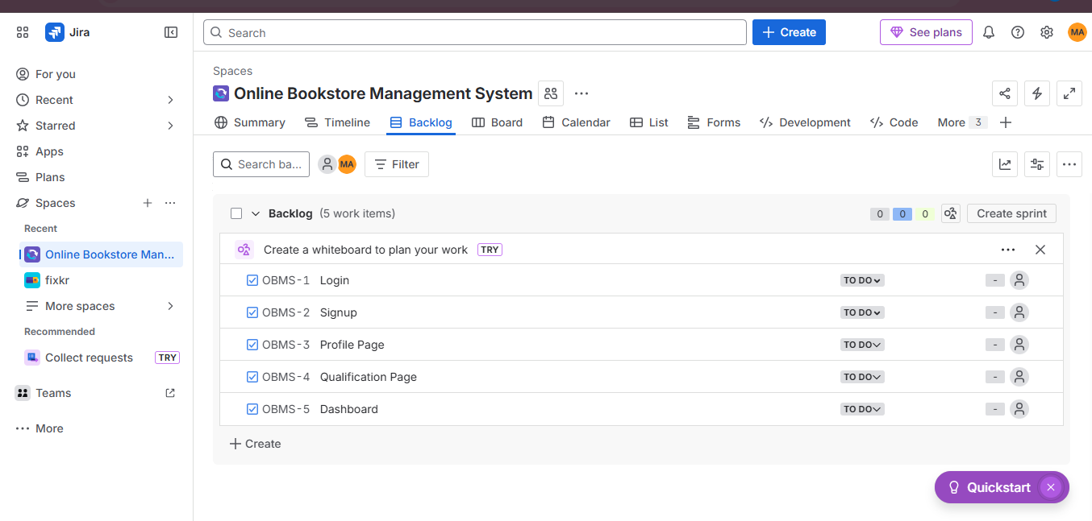

Task 3: Create Epics and Link Stories
Create 2 Epics (e.g., User Management, Book Management) and link relevant user stories under each epic.
Deliverable: Screenshot of Epics and linked stories.
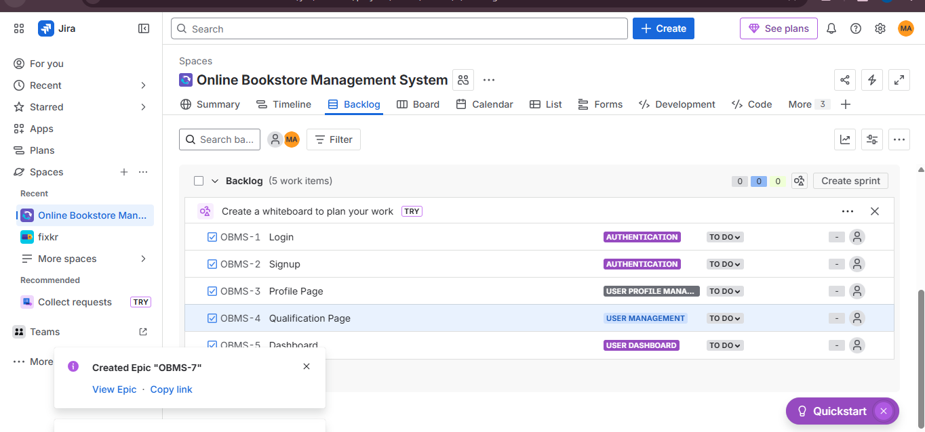

Task 4: Plan Your First Sprint
Name your sprint: Sprint 1 – User Account Features
Add 3 user stories from the backlog to this sprint.
Set sprint duration to 2 weeks and define a Sprint Goal.
Deliverable: Screenshot showing sprint name, goal, and added stories.
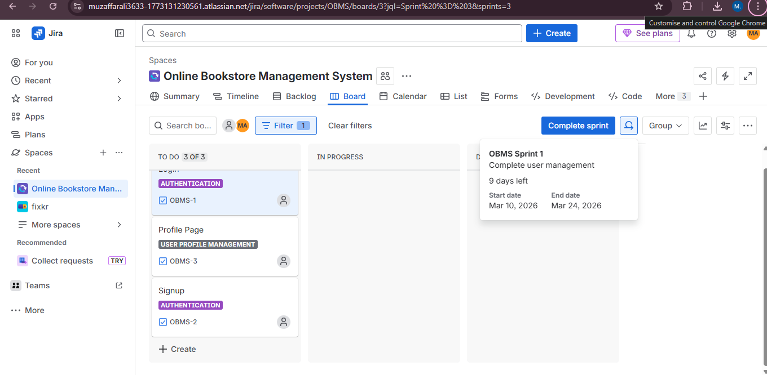

Task 5: Create and Assign Tasks
Break each user story into smaller tasks or subtasks and assign them to team members.
Example:
Story: “As a user, I want to register an account”
Task 1: Create registration form UI
Task 2: Implement validation logic (optional)
Task 3: Connect to database (optional)
Deliverable: Screenshot showing tasks and assignees.
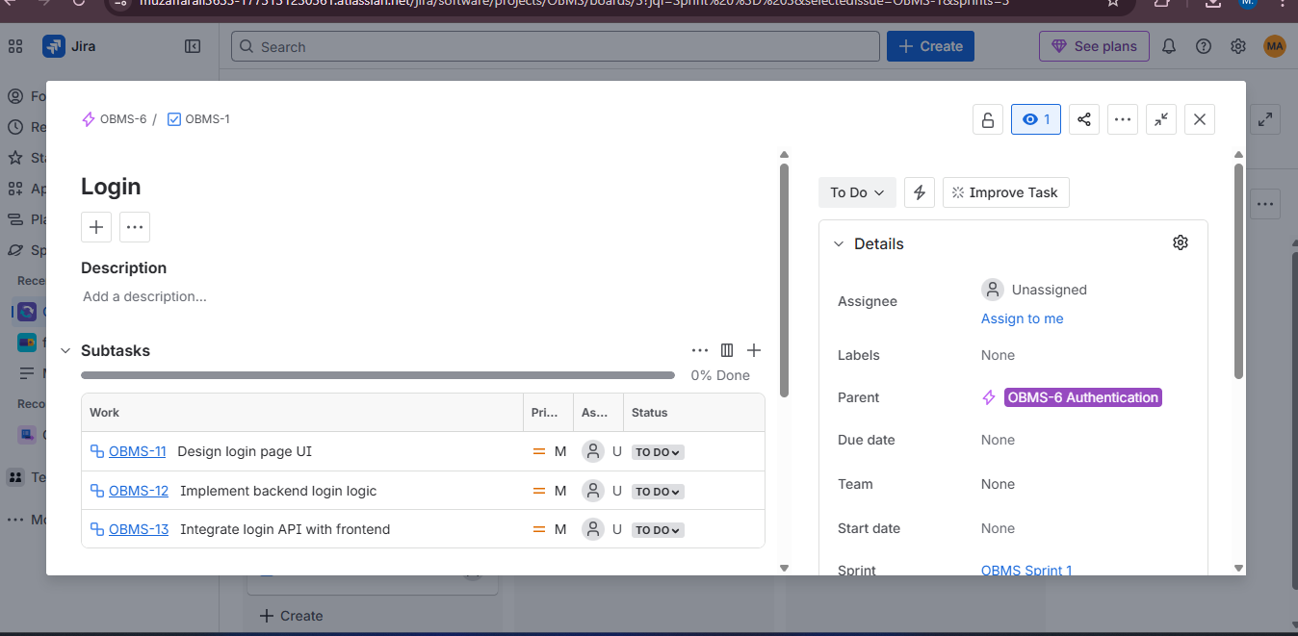

Task 6: Use Scrum Board for Tracking
Move tasks across columns on the Scrum Board:
To Do → In Progress → Done
Demonstrate progress tracking during sprint execution.
Deliverable: Screenshot of Scrum board showing progress.
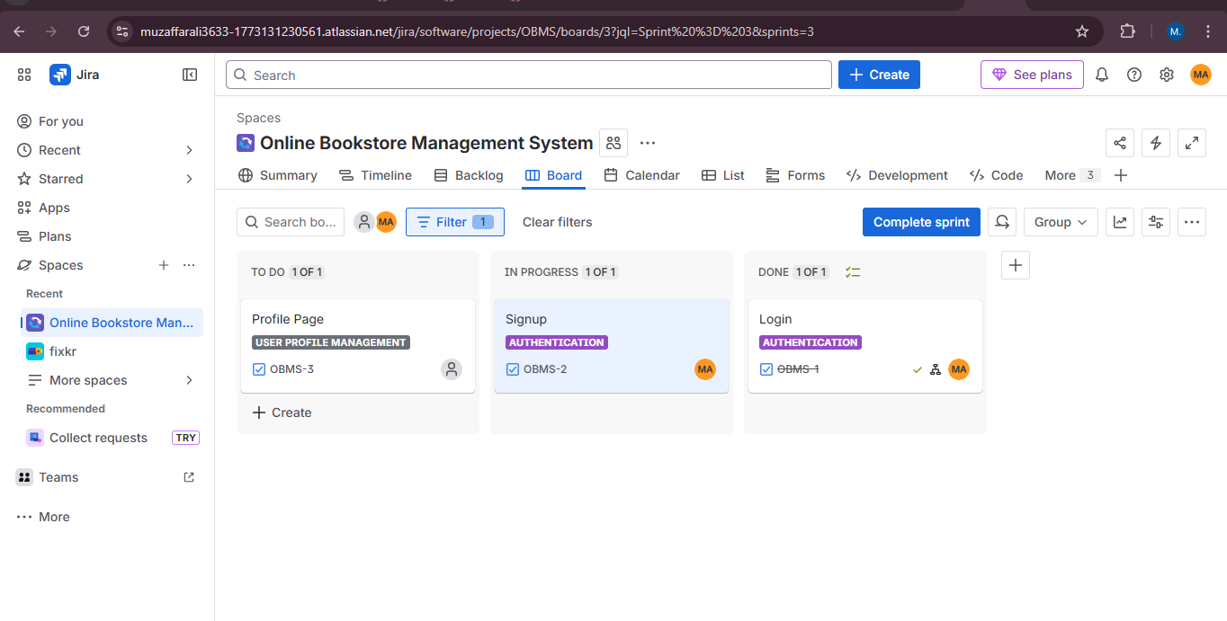

Task 7: Monitor Sprint Progress
Check the Burndown Chart and Sprint Report in Jira to observe team performance.
Deliverable: Screenshot of the Burndown chart.
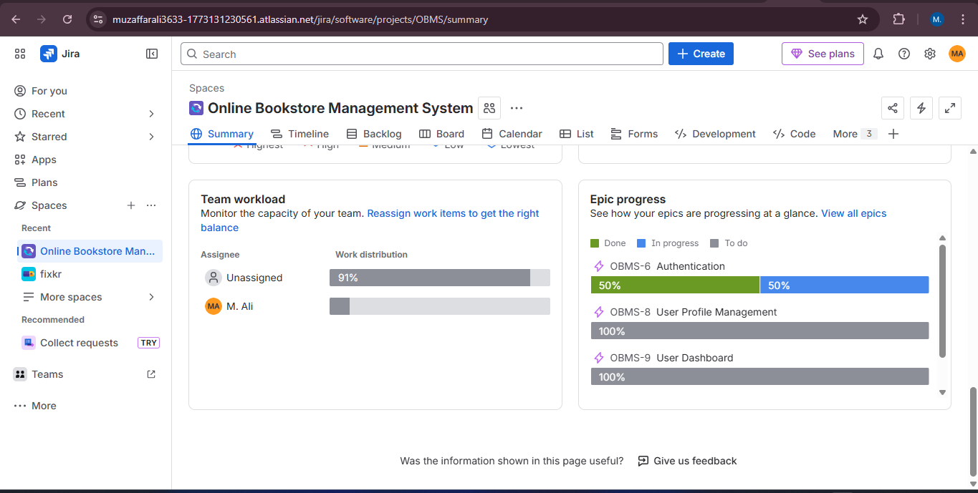

Task 8: Conduct Sprint Review and Retrospective
After closing Sprint 1:
Summarize completed and pending tasks.
Write 3 key points for Sprint Review and Retrospective, e.g. What went well and What didn’t go well and What could be improved in next sprint.
Deliverable: Short text summary (can be written in a Jira comment or Word file).
Sprint 1 Summary
Completed Tasks:
- Set up the project repository and development environment.
- Implemented basic UI structure for the application.
- Developed initial features including user interface components and basic functionality.
- Performed initial testing to ensure core features are working properly.
Pending Tasks:
- Integration of backend APIs with the frontend.
- Implementation of advanced features and additional modules.
- Further testing, debugging, and performance improvements.

